Professor Konkol

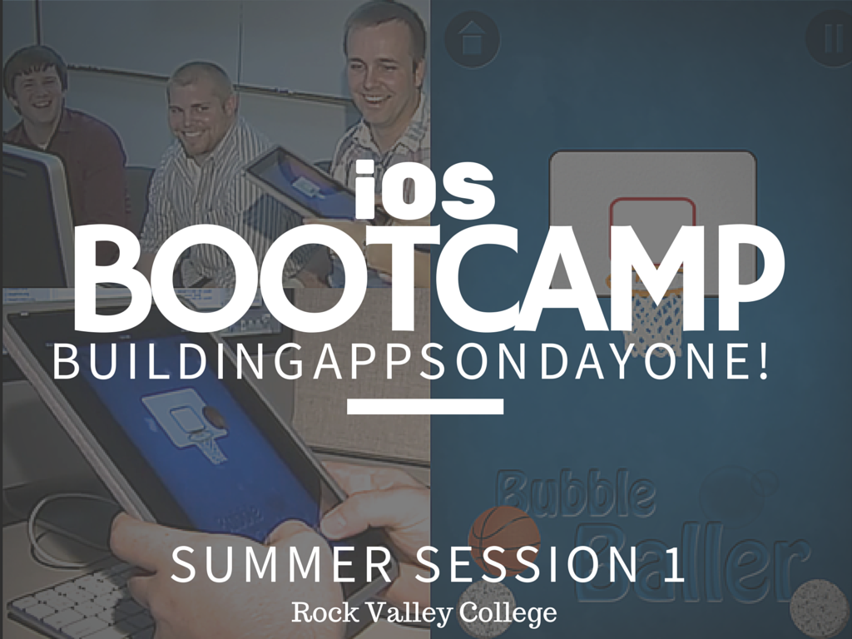

Swift

1. Getting Started
   1. Apple Developer Account
   2. XCode
   3. Mac
   4. iOS Device
2. Learning Swift Resources
   1. <http://learn-swift.co>
   2. <https://www.shinobicontrols.com/blog/posts/2014/07/16/ios8-day-by-day-index>
   3. <https://developer.apple.com/swift/resources/>
3. Download Book

* <https://www.gitbook.com/book/mhm5000/swift-cheat-sheet/details>

SpriteKit

* Sprite Kit is one of the best ways to make games on iOS. It’s easy to learn, powerful, and is fully-supported by Apple.
* Swift is an easy language to get started with, especially if you are a beginner to the iOS platform.

Resources

1. <http://www.spritekitlessons.com>
2. <http://www.raywenderlich.com/84434/sprite-kit-swift-tutorial-beginners>
3. <http://www.sprite-kit.com/>

Tutorial: BreakOut Game

GitHub: <https://github.com/ioscourse/SpriteKitSimpleGame>

